**MONGODB LAB ASSESSMENT**

**Q1**

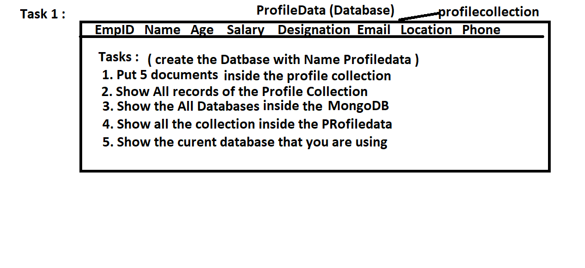

**Q 2:**

1. Show the Record where name="Amit"

2. Show the all records where location="mumbai"

3. Display people whose age is less than 25.

4. Display the document where salary<20000 & Designation is Developer

5. Display the document where salary between 20000 and 50000 and and location is Pune

**Q 3**

1. selects all documents from the ProfileCollection where the age is greater then 50

2. selects all documents from the ProfileCollection where Location equals either "Mumbai" or "Pune"  
 ( Do this task without using "in")

3. selects all documents from the ProfileCollection where Location

 equals either "Mumbai" or "Pune" (Do this task using "in")

4. selects all documents from the ProfileCollection where Location  not equal either "Mumbai" or "Pune" (Do this task using "in")

5. selects all documents from the ProfileCollection where the location  equals "Bangalore" and age is   
 less than 50

6. selects all documents in the Profilecollection where the Designation   
 equals "Developer" and either salary is less than 40000 or name starts with the character p

**Q 4 :**

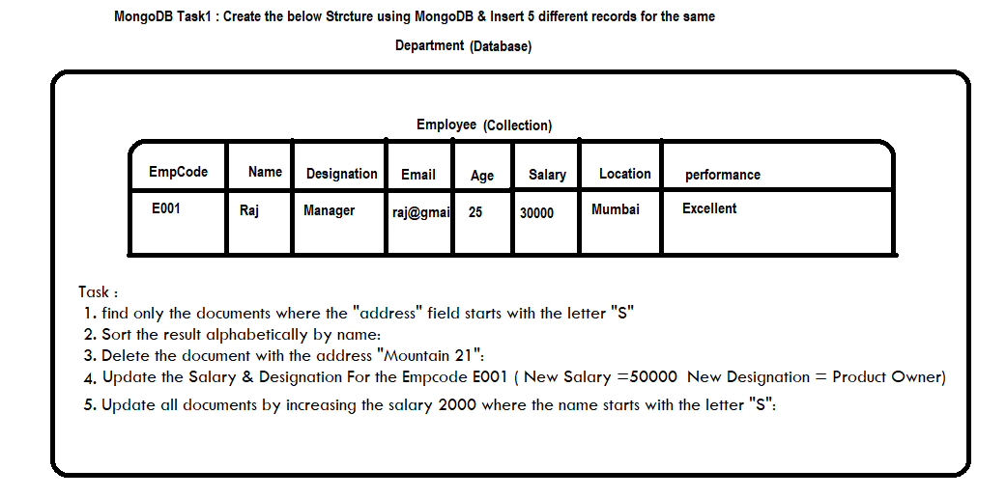

**Q 5.**

**Structure of 'restaurants' collection:**

{

"address": {

"building": "1007",

"coord": [ -73.856077, 40.848447 ],

"street": "Morris Park Ave",

"zipcode": "10462"

},

"borough": "Bronx",

"cuisine": "Bakery",

"grades": [

{ "date": { "$date": 1393804800000 }, "grade": "A", "score": 2 },

{ "date": { "$date": 1378857600000 }, "grade": "A", "score": 6 },

{ "date": { "$date": 1358985600000 }, "grade": "A", "score": 10 },

{ "date": { "$date": 1322006400000 }, "grade": "A", "score": 9 },

{ "date": { "$date": 1299715200000 }, "grade": "B", "score": 14 }

],

"name": "Morris Park Bake Shop",

"restaurant_id": "30075445"

}

1. Write a MongoDB query to display all the restaurant which is in the borough Bronx.

2. Write a MongoDB query to display the first 5 restaurant which is in the borough Bronx.

3.Write a MongoDB query to display the next 5 restaurants after skipping first 5 which are in the borough Bronx.

4. Write a MongoDB query to find the restaurants who achieved a score more than 90.

5. Write a MongoDB query to find the restaurants that achieved a score, more than 80 but less than 100.

6. Write a MongoDB query to arrange the name of the restaurants in ascending order along with all the columns.

7. Write a MongoDB query to arrange the name of the restaurants in descending along with all the columns.

8. Write a MongoDB query to arranged the name of the cuisine in ascending order and for that same cuisine borough should be in descending order.

9. Write a MongoDB query to know whether all the addresses contains the street or not.

10. Write a MongoDB query which will select all documents in the restaurants collection where the coord field value is Double.

**Q 6.**

